**How to install pir motion sensor**

info: in this step by step guide I will explain how to install a pir motion sensor. There will of course be pictures to help you with this guide. The photos also make the guide shorter and clearer for the person who wants to perform this installation.

Step 1:

What do you need:

1. 1x batterij rond de 9v (volt)

2. 5x connection cables

4. 1x resistor

5. 1x led

6. 1x pir motion sensor

7. 3x jumpwires (female to male)

8. 1x anti static band

Step 2:

First of all, safety, you must always wear your anti static strap for safety. This is of course the most important step.

Step 3:

According to the photo indicated, you will try to install all cables and connect them to the sensor and battery as best as possible, based on the guidelines and the what do you need list.

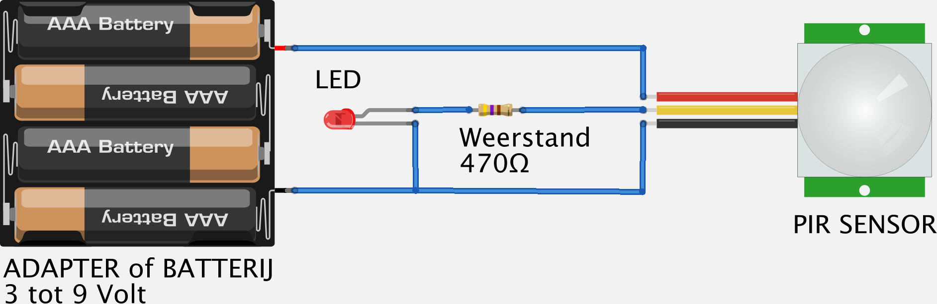

Step 4:

Test the sensor and check that everything is reported to be working properly. If everything works fine and the light is on on command, the installation is complete. If not, you should check that all cables are properly connected and then you should test it again. After this tip everything should work fine and this pir motion sensor installation is successful.

This is what the end product should look like:

